# Installing Java GRS Agent Version 2.0 on VM

The Java grs-agent v2.0 should be running on the virtual machine which you want to use for GRS remote Execution.

**Note:** If you have any of the software mentioned below already installed, only check whether the environment variables are correctly configured or not.

Step 1:

Install Java JDK 1.8 version (whatever is the latest version) on the virtual machine. You can refer below URL if any help is required.

<http://www.wikihow.com/Install-the-Java-Software-Development-Kit>

**Note:** Don’t forget to configure System Environment Variable **JAVA_HOME** and also edit the **Path** variable and append jdk home path ex: “C:\Program Files\Java\jdk1.8.0_25\bin”

## Step 2:

Install latest Maven version on the virtual machine and configure the Environment variables. You can refer below URL if any help is required.

<http://www.mkyong.com/maven/how-to-install-maven-in-windows/>

**Note:** Don’t forget to add environment variable **M2_HOME** and also edit the **Path** variable and append maven home path ex: “C:\apache-maven\bin”

## Step 3:

Download Git software from below URL and Install it by selecting Next button continuously. (Don’t change the default settings shown while installing Git)

<https://git-scm.com/downloads>

**Note:** Environment variables will be automatically added by the Git software Setup. You don’t need to configure them manually.

## Step 4:

Download **One Click Installation** file of Java grs-agent v2.0 from GRS Website (<http://grs.amers1.cis.trcloud/nggrs/>).

You can find the software download link in Change project page.

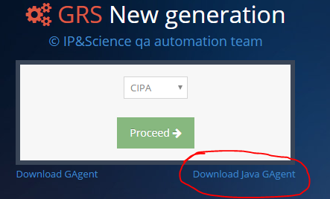

## Step 5:

Extract the downloaded zip file and run the software “**Start_GAgent.exe**” using administrator privileges.

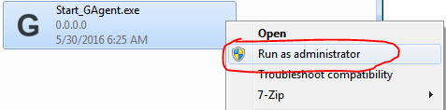

**Note:** The program will automatically download Java grs-agent from repository and automatically starts the agent. (You can see the message GRS agent service is up and running after some time)



## Step 6:

The one click installation file also creates a shortcut “**Start-GAgent v2.0.bat”** on your desktop.

You should run the **Start-GAgent v2.0.bat** file with administrator privileges **whenever you want to restart** the grs-agent service. (In short you should close the already opened command prompt and run the Start-GAgent v2.0.bat file whenever you want service to be restarted).

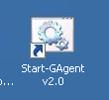

## Step 7: Adding Java grs-agent v2.0 to windows automatic startup programs list

In order to add GAgent v2.0 to windows startup programs list so that after each login attempt the program will automatically start, please follow the below steps

1. On start menu All Programs list find a folder called **Startup** and Right click on it and Select **Explore All Users** option

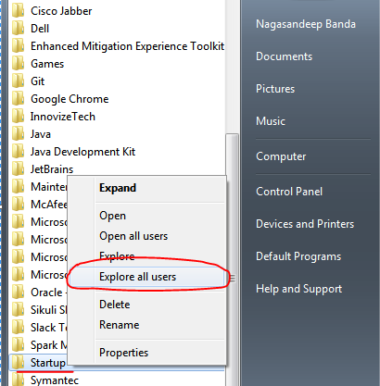

1. One Folder will be opened. Copy paste the shortcut on your Desktop “**Start-GAgent v2.0.bat**” to that folder

# Configuring GRS Website - Project Settings for GIT compatibility

1. Go to your project settings (Configuration->Project->Settings)
2. Select **GIT radio button** and in the text box **enter the GIT repository path** of your project
3. Click on the **Submit** button
4. After submitting click the button **Update Tests** (**Note:** This will update feature files and tags of your project. Whenever you make changes or introduce new feature files for your project you need to update tests by clicking this button)

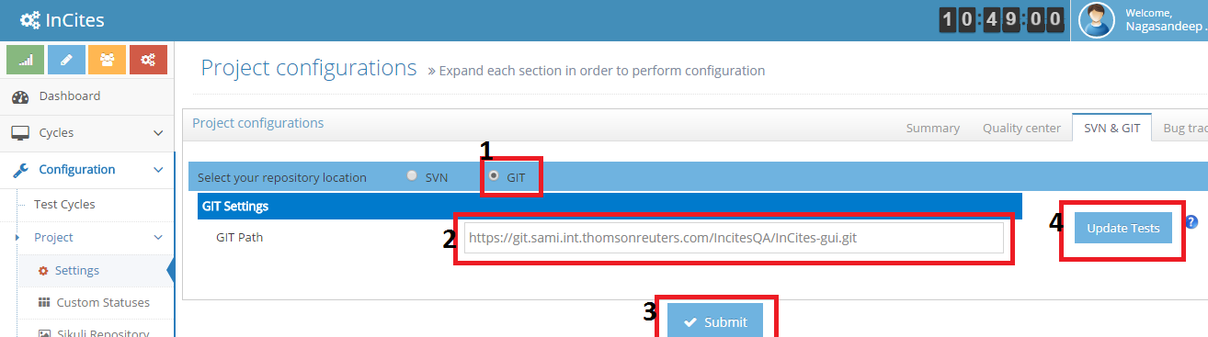

# Running Test Cases from GRS on the VM

1. Expand the Button **Execution** -> **New** in GRS Website
2. Select **Load Balanced** or **Linear Execution** depending on your requirement
3. Make sure that in the Virtual Machine **grs-agent service** is up and running
4. Add the test cases to a particular machine by clicking **Add Tests** option
5. Choose the configuration for the execution like Browser, Test Cycle Name, Username, and Password etc.
6. Click the Ping Button to test whether GRS Website is able to reach the VM or not. (**Green** color appeared means GRS website is able to reach the VM. If **orange** color appears make sure that in VM grs-agent service is up and running, if not click **Start-GAgent v2.0.bat** file and run grs agent service)
7. Click the Start option to start executing the test cases in that particular virtual machine

